**An IoT Based Approach to Design An Effective Air Pollution Monitoring System**

***Project Report***

***Submitted By***

1. **Aliul Nadab, Roll- 1220CMSH-0034, Reg. No. 121-1117-0725-20**
2. **Rohit Neogi, Roll- 1220CMSH-0046, Reg. No. 121-1111-0737-20**
3. **Tushar Ghosh, Roll- 1220CMSH-0061, Reg. No. 121-1115-0752-20**

***Department of Computer Science***

**Gour Mahavidyalaya**

**Malda**

**August, 2023**

*BONAFIDE CERTIFICATE*

This is to certify that this project report entitled “**An IoT Based Approach To Design An Effective Air Pollution Monitoring System**” submitted to Gour Mahavidyalaya, Malda, is a bonafide record of work done by “Aliul Nadab, Rohit Neogi and Tushar Ghosh” under my supervision for the session of 2022-23.

***Arijit Bhattacharya***

**Assistant Professor**

**Department of Computer Science**

**Gour Mahavidyalaya**

**Malda**

**Declaration by Author(s)**

This is to declare that this report has been written by us. No part of the report is plagiarized from other sources. All information included from other sources has been duly acknowledged. We aver that if any part of the report is found to be plagiarized, we are shall take full responsibility for it.

Aliul Nadab

Rohit Neogi

Tushar Ghosh

**Table of Contents**

1. Introduction Page- 5-6
2. Literature Review Page- 6-7
3. Methodology Page- 7
   1. Architecture Page- 9
   2. Working Principal Page- 9-10
   3. Mathematical Analysis of Proposed Model Page- 10-12
4. Result & Discussion Page- 12-36
5. Conclusion Page- 36
6. References Page- 37-38

**Keywords-**Internet of Things, Pollution, Air, Pollution, Python, MQ6, MQ9, MQ135, Arduino UNO, Quality, Matplotlib

**Abstract**

*Air pollution is a major public health problem, and understanding the areas that are most affected is essential for developing effective mitigation strategies. Storing and analyzing air pollution data can help to identify these areas and track changes in air quality over time [1]. The necessity to monitor air quality is readily apparent due to the substantial growth in industrial activities over recent years.* *This project presents an air quality monitoring system aimed at addressing the growing concern of air pollution resulting from industrial activities.* *The system was created utilizing the Arduino microcontroller platform to ensure a unique and effective solution for monitoring air pollution.* *The air pollution monitoring system was purposefully designed to provide real-time monitoring and analysis of air quality, while securely storing the collected data for further analysis and assessment.* *Air quality measurements were recorded in Parts per Million (PPM) [2] metrics and analyzed using Microsoft Excel for accurate assessment and analysis. The air quality measurements obtained from the designed system were highly accurate, reflecting the system's effectiveness in assessing air quality conditions. From the Microsoft Excel generated data sheets specific to different areas, enabling the identification of periods with low pollution levels in each respective area. This facilitated the ability to pinpoint the times when air quality was comparatively less polluted in each area.*

1. **Introduction**

Air, the primary component of our atmosphere, is made up of a number of gases, including nitrogen, carbon dioxide, carbon monoxide, and minute amounts of rare elements [3]. Living in a clean, unpolluted environment is necessary for humans to maintain life and good health [4]. Changing the air's natural form in any way could have a negative impact on all life on Earth. Air pollution is referred to as the presence of one or more risky substances, such as gases, in the atmosphere at levels that could endanger humans, animals, or plants [5]. Air pollutants fall into two major categories: primary pollutants and secondary pollutants. Primary pollutants are directly emitted into the atmosphere from various sources such as vehicles, industrial emissions, and burning of fossil fuels [6]. On the other hand, secondary pollutants are formed when primary pollutants undergo chemical reactions with other substances present in the atmosphere [6]. The impact of air pollution on human health can be severe, leading to various health issues such as difficulty in breathing, persistent coughing, and exacerbation of respiratory conditions like asthma and emphysema [5]. Additionally, polluted air can reduce visibility, causing haziness and obscuring distant objects. The consequences of air pollution are alarming, resulting in approximately 7 million premature deaths worldwide each year, accounting for one in eight premature deaths annually [7]. Tragically, children bear a significant burden of the health effects of air pollution. An estimated 570,000 children under the age of five die every year due to respiratory infections linked to indoor and outdoor air pollution, including exposure to second-hand smoke [8]. Children exposed to air pollution are at a higher risk of developing chronic respiratory problems like asthma later in life [9]. To combat air pollution effectively, researchers across the globe have developed models for monitoring various pollutants such as Carbon Monoxide (CO), Carbon Dioxide (CO2), Ammonium (NH4), and more. These monitoring systems aim to assess air quality and provide crucial data to address pollution-related issues. This paper concentrates on devising and implementing an air pollutant monitoring system. The system utilizes three gas sensors, Arduino microcontroller, to measure, analyze, and log air quality data. The primary goal is to establish an air pollution monitoring framework capable of continuously tracking and transmitting real-time air quality information. The data collection process involves utilizing Microsoft Excel to generate specific data sheets tailored to different geographical areas. These data sheets enable researchers to discern periods with low pollution levels in each respective area. Using this data sheets, and the power of Python’s Matplotlib library, it is possible to get a better understanding of air pollution levels.

1. **Literature Review**

Arduino Poonam Pal1, Ritik Gupta2, Sanjana Tiwari3, Ashutosh Sharma4 [10] aims to address the increasing air pollution caused by various factors such as population growth, vehicle use, industrialization, and urbanization, which directly impacts human health. To combat this, an IoT-based Air Pollution Monitoring System has been developed. The system uses internet connectivity and a web server to monitor air quality and detect harmful gases like CO2, smoke, alcohol, benzene, and NH3. It provides real-time air quality data on an LCD screen and a webpage, accessible from computers or mobile devices, enabling users to take informed actions to safeguard their well-being and the environment.

Harsh N. Shah 1 , Zishan Khan 2 , Abbas Ali Merchant 3 , Moin Moghal 4 , Aamir Shaikh 5 , Priti Rane 6 [11] Air pollution is a major health concern, causing various respiratory and cardiovascular issues, and even premature deaths worldwide. To address this problem, we've developed an IoT-based Air Pollution Monitoring System. This system continuously tracks air quality, detecting harmful gases like CO2, smoke, and others. When pollution levels exceed safe limits, it triggers an alarm and displays the data on an LCD screen and webpage for easy monitoring. With this system, we aim to improve public health and create a safer environment for everyone.

Ch.V.Saikumar M.Reji P.C.Kishoreraja [12] aims to monitor air quality in industrial and urban areas using gas sensors (CO and NO2) and IoT technology. It utilizes an Arduino platform for data communication and a Wireless Sensor Network (WSN) for real-time monitoring. However, the paper has issues with sensor calibration and converting output values to the standard unit (PPM). Using two sensors draws more power and leads to unpredictable readings. Despite potential, improvements are needed for accurate and reliable air quality monitoring.

Riteeka Nayak , Malaya Ranjan Panigrahy , Vivek Kumar Rai , T Appa Rao [13] present an IoT-based Air Pollution Monitoring System using the MQ135 sensor for accurate gas detection. The system allows remote air quality monitoring through a web server and triggers alarms when harmful gas levels surpass safe limits.

Kennedy Okokpujie, Etinosa Noma-Osaghae, Odusami Modupe, Samuel John and Oluga Oluwatosin [14] says In the Arduino-based Air Pollution Monitoring System, the MQ135 sensor collected air quality data, which was displayed on an LCD screen and transmitted to a Wi-Fi module. The calibrated sensor ensured accurate measurements in Parts per Million (ppm). The Wi-Fi module sent the data to a remote server application called "ThingSpeak" via the internet, allowing global access to the measured data from any internet-connected device. The system successfully provided real-time air quality information for monitoring and analysis.

1. **Methodology**

The model is designed using an Arduino UNO microcontroller and MQ6, MQ9, and MQ135 Gas sensors. Figure 1 introduced the system overview. Figure 2 introduces the working diagram. In figure3, the flowchart is displayed.

The system of the design was sequence in five layers, as demonstrated in figure 1. The first layer describes environmental measurable parameters. The second layer says analysis the features of detectors. The third layer defines the decision by detecting, calculating, defining the boundary, space, and scheduling over a time period. The fourth layer was collection of the detector’s data. The fifth layer represents the smart environment. The detector collected data whenever it was actuated by the microcontroller. **The sixth layer refers to what we wrote manually in Excel to explain the information from the detectors we got and make a set to present the information as a data visualization module in Python. The design requirements for the suggested system are described in Table 1.**

|  |  |  |
| --- | --- | --- |
| **S/N** | **Component Required** | **Quantity** |
| 1 | Arduino UNO | 1 |
| 2 | MQ 6 Sensor | 1 |
| 3 | MQ 9 Sensor | 1 |
| 4 | MQ 135 Sensor | 1 |
| 5 | Bread Board | 1 |
| 6 | Connecting Wires | Any Amount |

**Table 1** The Design Specification

Indicate Environmental Measurable Parameters

Layer -1

Analysis the features of sensors or detectors

Layer -2

Decision takes by detecting, calculating, defining the boundary, space, and scheduling over a time period

Layer -3

Collection of sensors data

Layer -4

Layer -5

Smart Environment

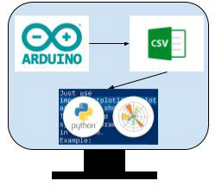

Layer -6

**Figure 1** – Overview of the system

* 1. **Architecture**

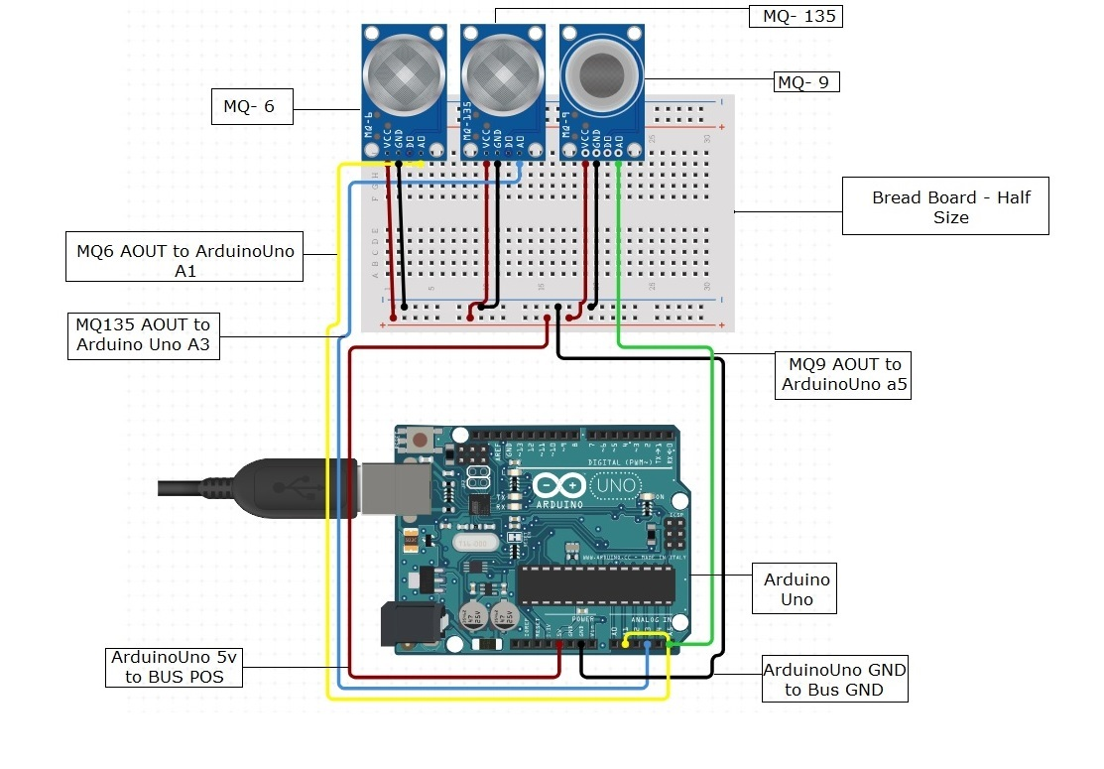

**Figure 2** – Architecture of the system

* 1. **Working Principle of The Proposed Model**

As said by figure 3, When the Arduino library was activated and a message was sent the output to serial monitor. Using the MQ135, MQ6, MQ9 sensor, air quality information was gathered. The sensors analog output voltage changed proportionately to the amounts of polluting gases measured in Parts per Million (ppm). The Data Is first displayed on the serial monitor then we recorded it manually in excel sheet. After making the set with amounts of gases as csv file then we average the data set according to time as per minute, then we visualize as a time-series pattern graph with the help of Python’s Matplot library.

IF No

Check Connection

Load Libraries on the sensors and define pins

Error shows in serial monitor

IF yes

Manually type the data and store as csv file and visualize it

Display data on serial monitor using Arduino Uno

Collect data from MQ6, MQ9, MQ135 sensors

**Figure 3** –Flowchart of the system

* 1. **Mathematical Analysis of Proposed Model**

The level concentration of pollutants in the air is measured in Parts per million(ppm) or percentage.

Lets understand a gas sensor, the concentration of a gas in part per million (ppm) according to the resistance ratio of the sensor (RS/R0). RS is the resistance of the sensor that changes depending on the concentration of gas, and R0 is the resistance of the sensor at a known concentration without the presence of other gases, or in fresh air [15].

**Calculations**

We can derive a formula to find RS using Ohm's Law:

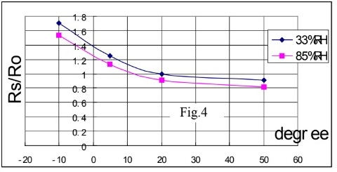  V = I x R

Where V is voltage, I is current, and R is resistance.

Where V is voltage, I is current, and R is resistance. Looking back at the circuit from Figure 1, we can see that RS, which is the resistor between pins A and B, and RL are in series.

From Ohm’s Law, we can derive I as follows:

  I = V / R

Which in our circuit is equal to:

  I = VC / (RS+RL)

we can obtain the output voltage at the load resistor using the value obtained for I and Ohm’s Law.

V = I x R

VRL = [VC / (RS + RL)] x RL

VRL = (VC x RL) / (RS + RL)

So now we solve for RS:

VRL x (RS + RL) = VC x RL

(VRL x RS) + (VRL x RL) = VC x RL

(VRL x RS) = (VC x RL) - (VRL x RL)

RS = [(VC x RL) - (VRL x RL)] / VRL

RS = [(VC x RL) / VRL] - RL

This formula will help us find the values of the sensor resistance for different gases.

Example: -

1. Calibration Parameters:

- A = 10.2

- B = 1.8

2. Measured Resistance Values:

- Rs = 58.3 ohms (Sensor Resistance in the target gas environment)

- R0 = 11.7 ohms (Sensor Resistance in clean air)

3. Calculate the Ratio (Rs/R0):

Ratio (Rs/R0) = Rs / R0 = 58.3 ohms / 11.7 ohms = 4.983

4. Apply the Calibration Equation:

PPM = A * (Rs/R0) ^B

5. Calculate the Gas Concentration (PPM):

PPM = 10.2 * (4.983) ^1.8

PPM = 10.2 * 38.124

PPM = 388.7448, We denote it as percentage 388.7448/100 = 3.887.

So, the gas concentration is approximately 388.74 PPM for the specific gas being detected by the sensor. The equation `PPM = 10.2 * (Rs/R0) ^1.8` is used to convert the sensor resistance ratio (Rs/R0) into the gas concentration in parts per million (PPM) using the calibration parameters A and B.

1. **Results And Discussion**

The serial monitor used to analyze the air quality data got from sensors in this proposed system. Serial Monitor is an essential tool when creating projects through Arduino [16]. It used as a debugging tool, testing out concepts or to communicate directly with the Arduino board [16]. This shows us the sensor’s data which is updated frequently by programs developed for sensors. Then we manually type from it and make a csv file, then we average the data set according to time as per minute, which we then visualize as a time-series pattern graph with the help of Python’s Matplot library.

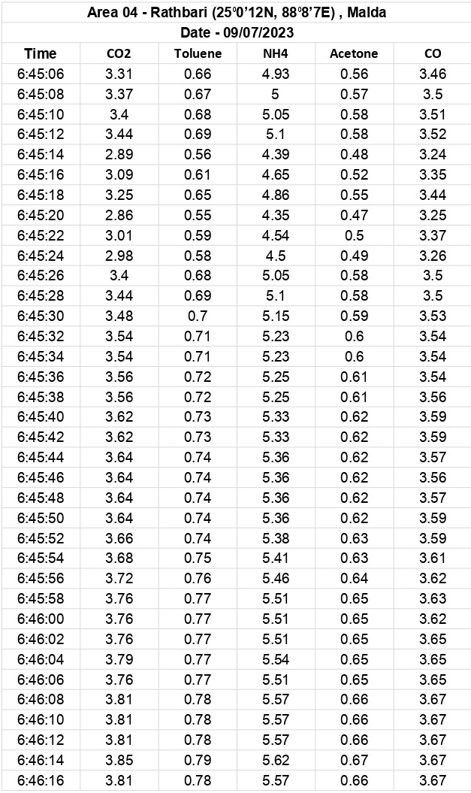

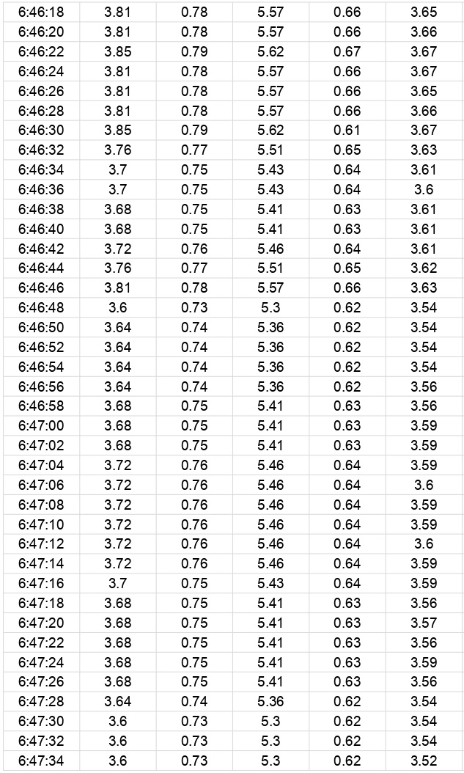

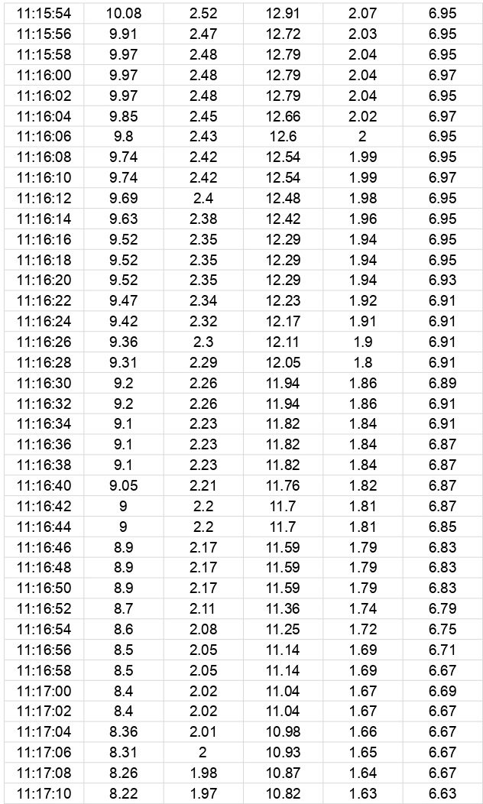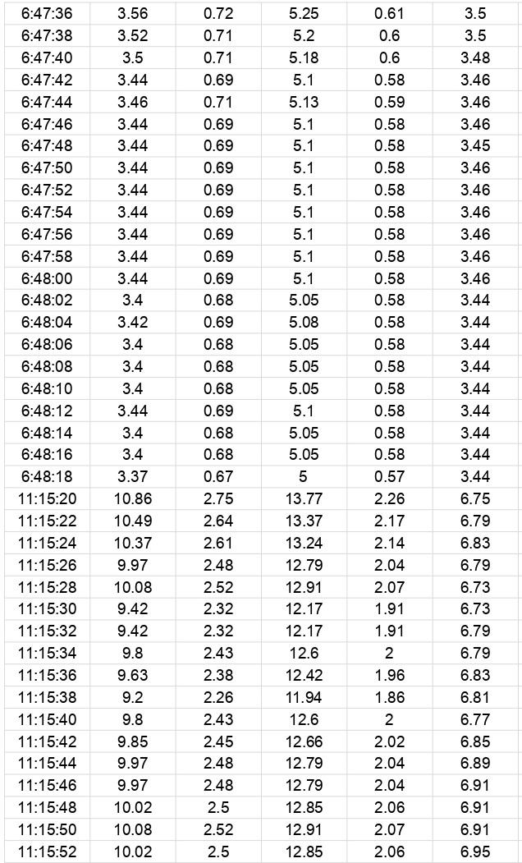

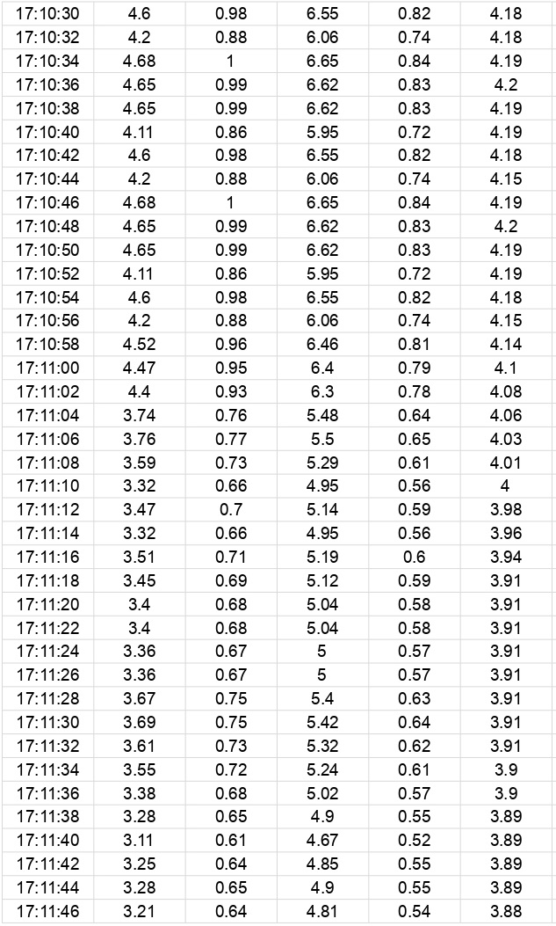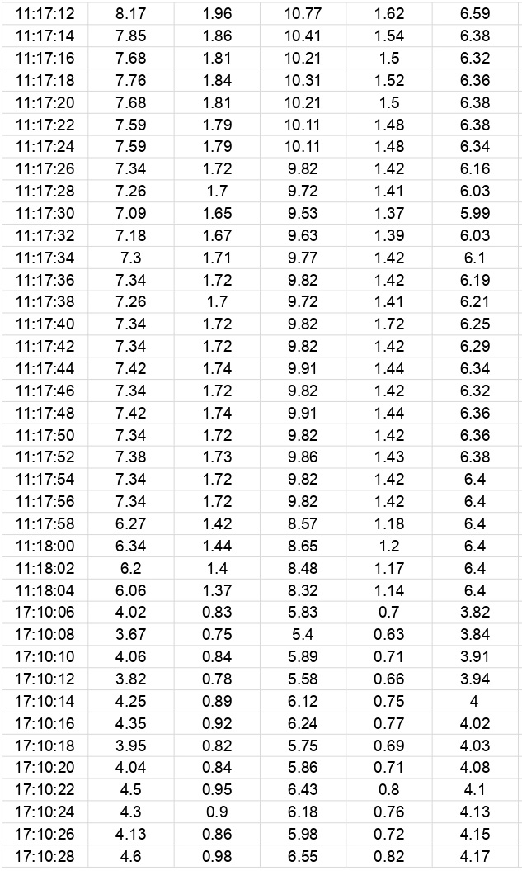

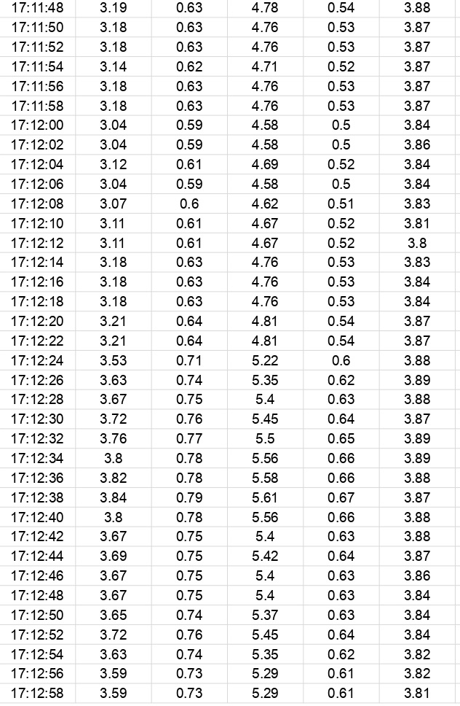

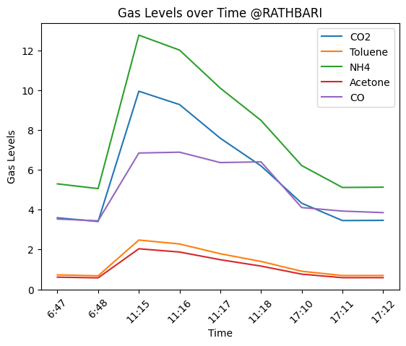

**Figure 5.** Air quality of Rathbari

Visualize this to better Under standing

For making Data Visualization We make Average this dataset to per minute time wise

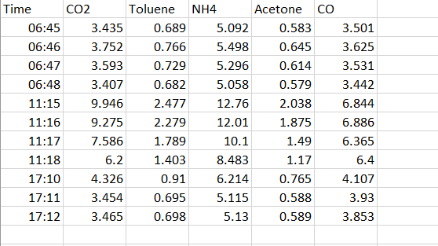

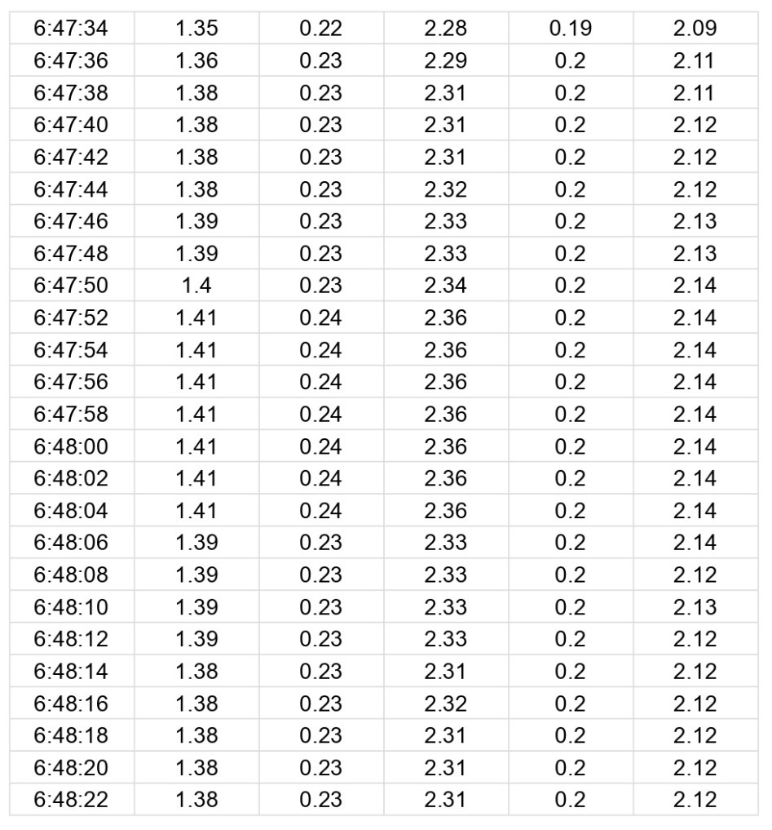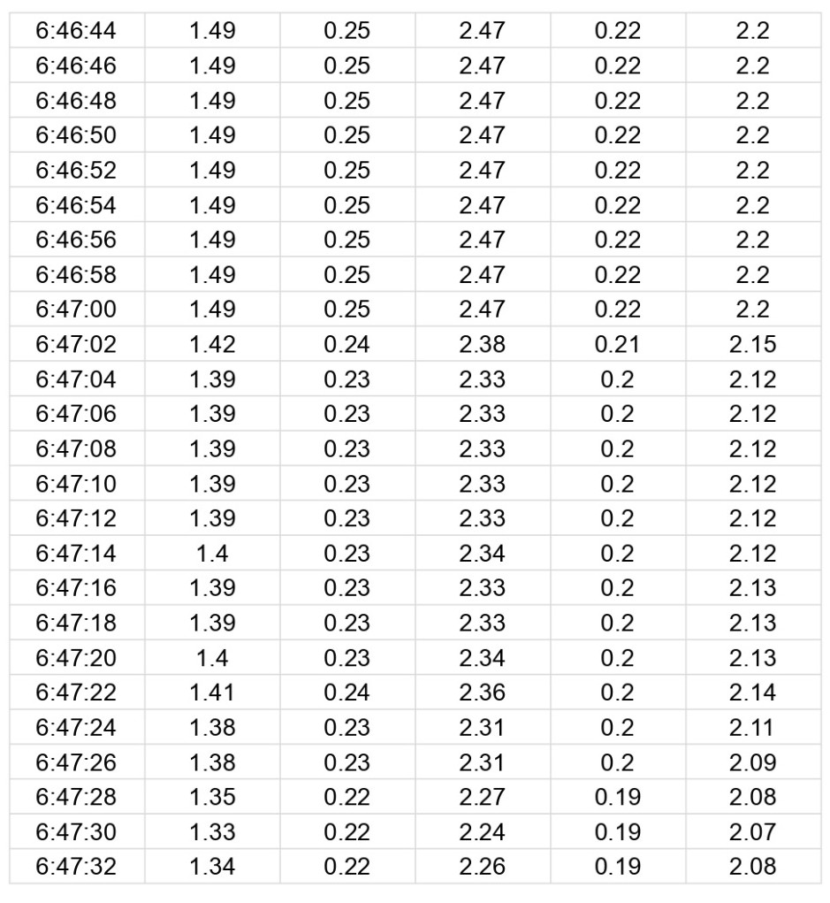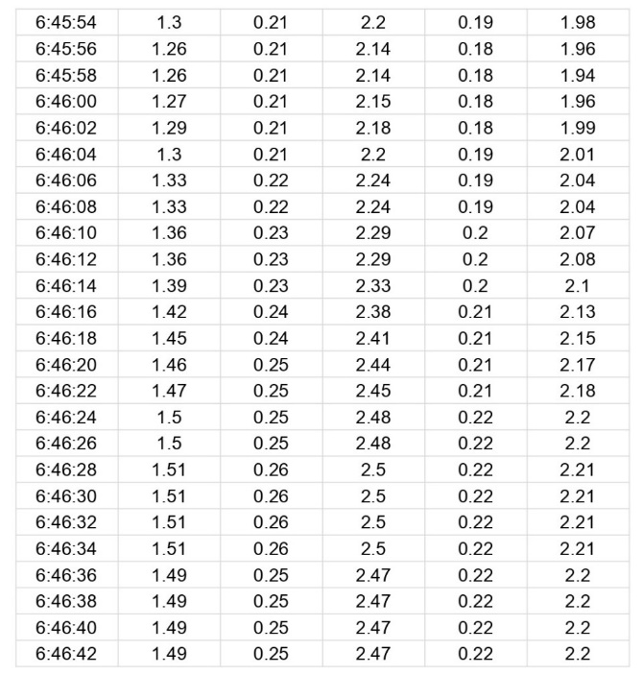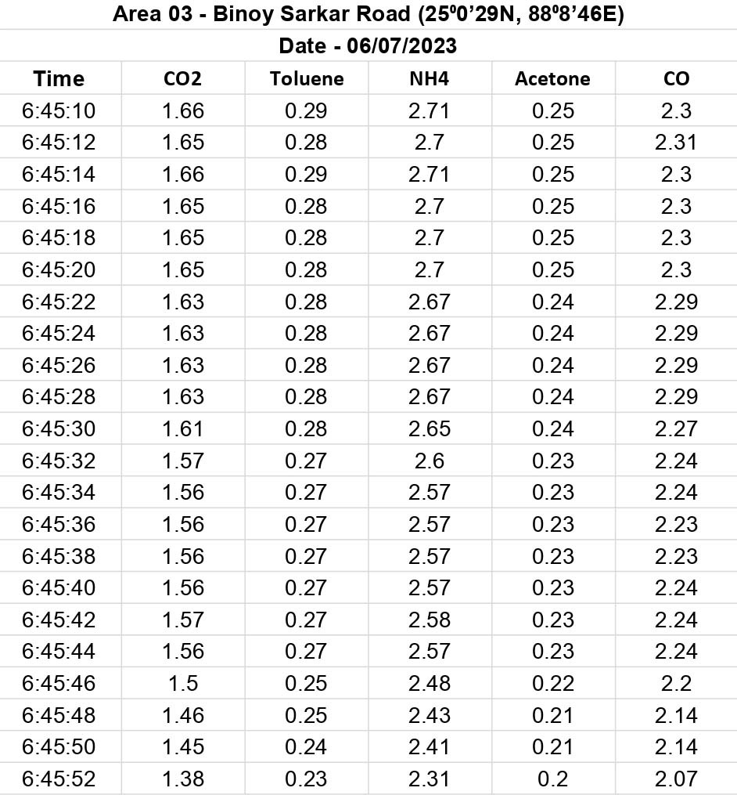

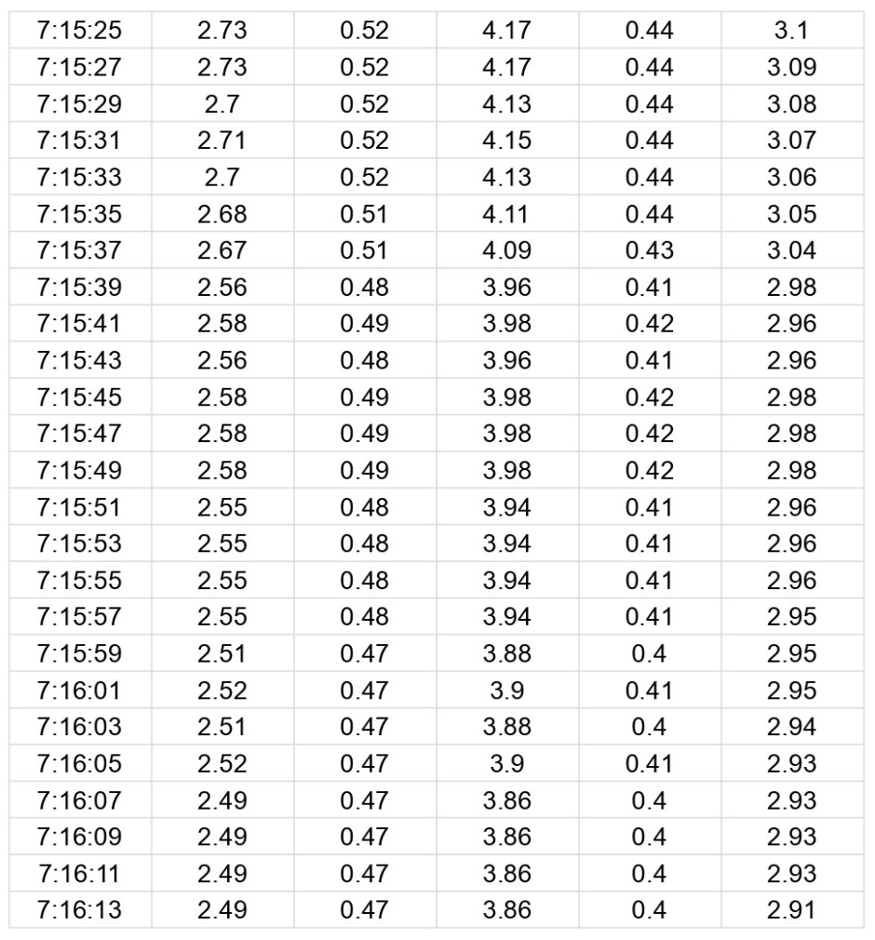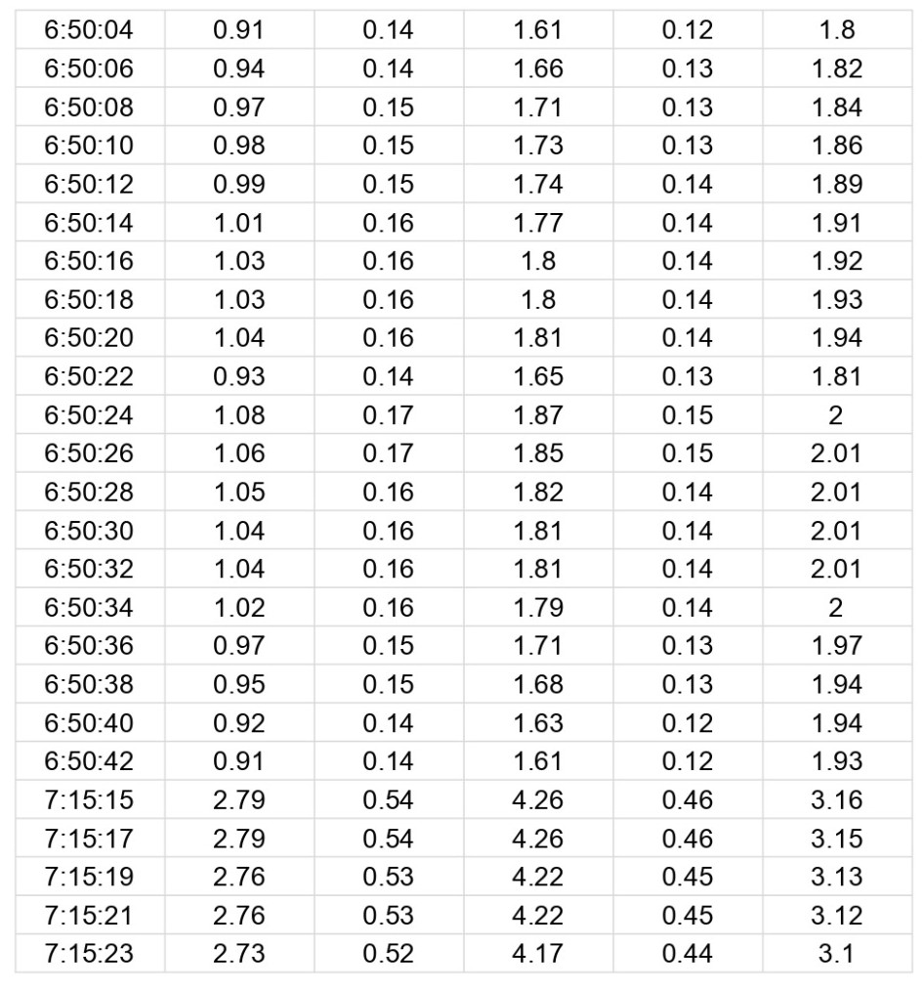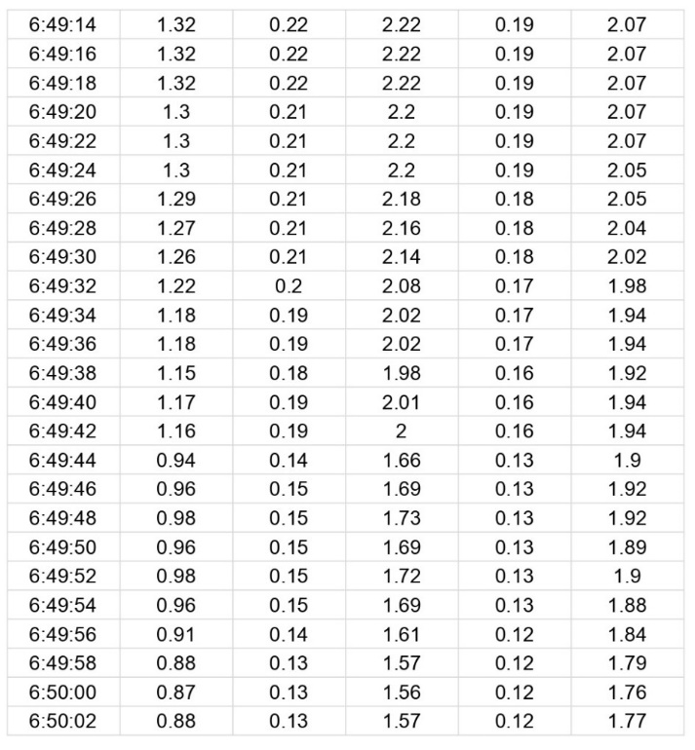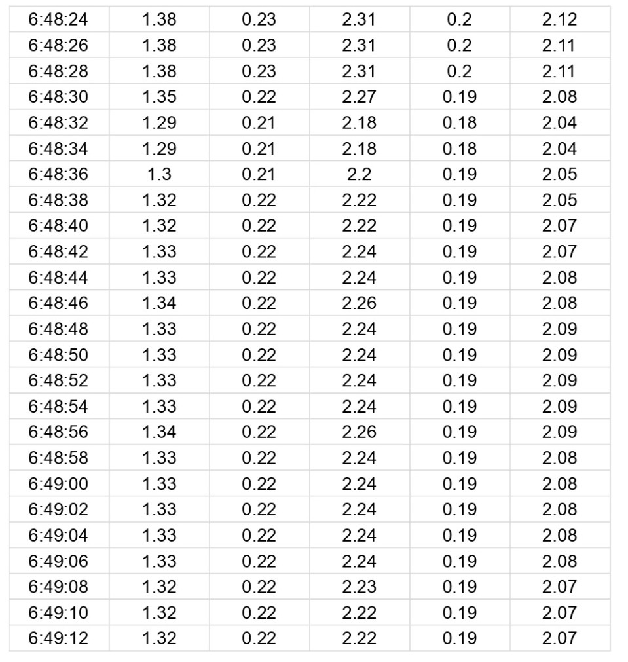

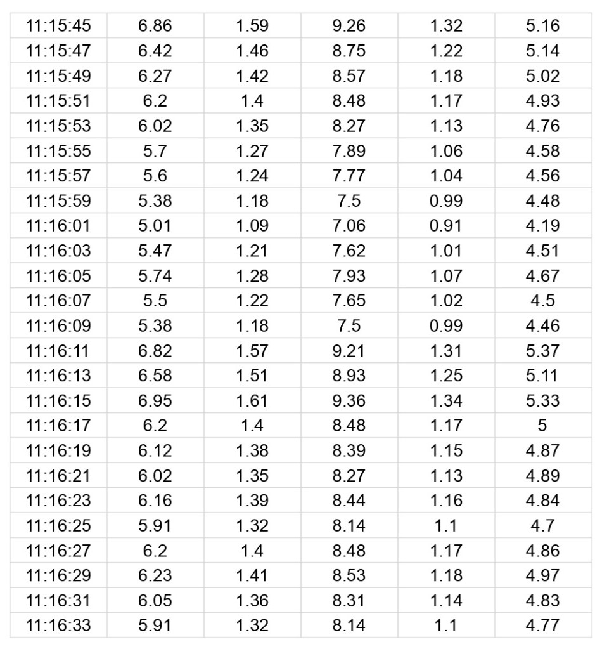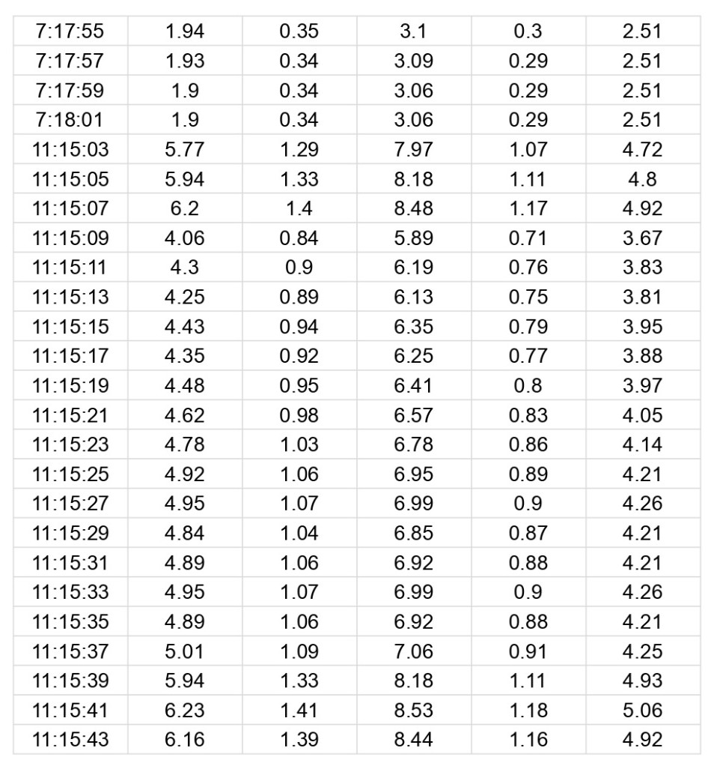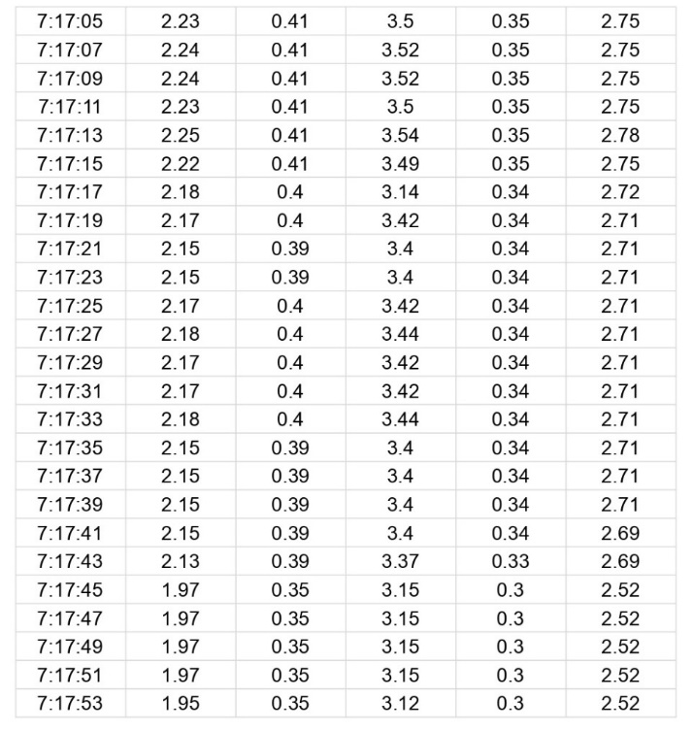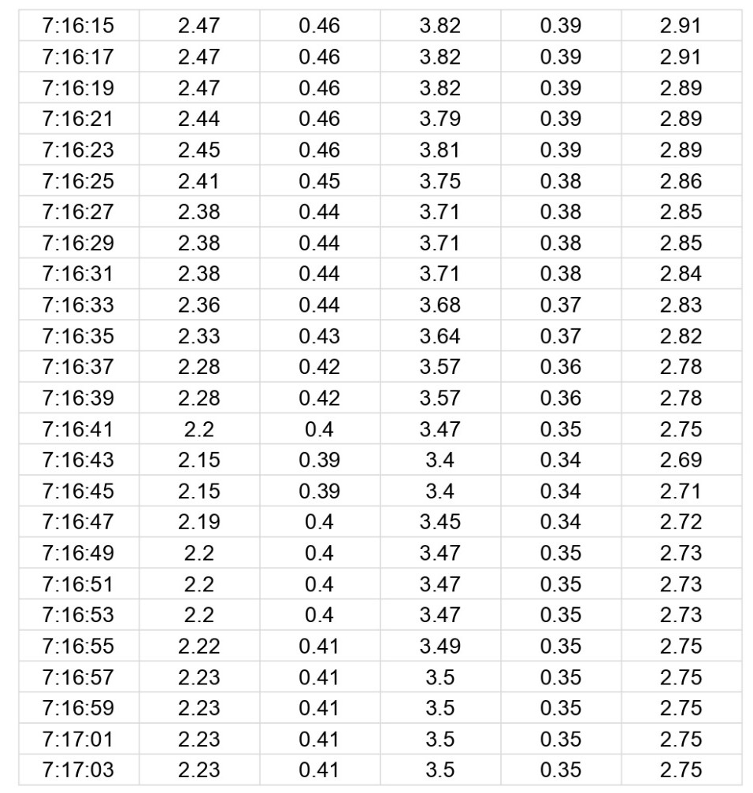

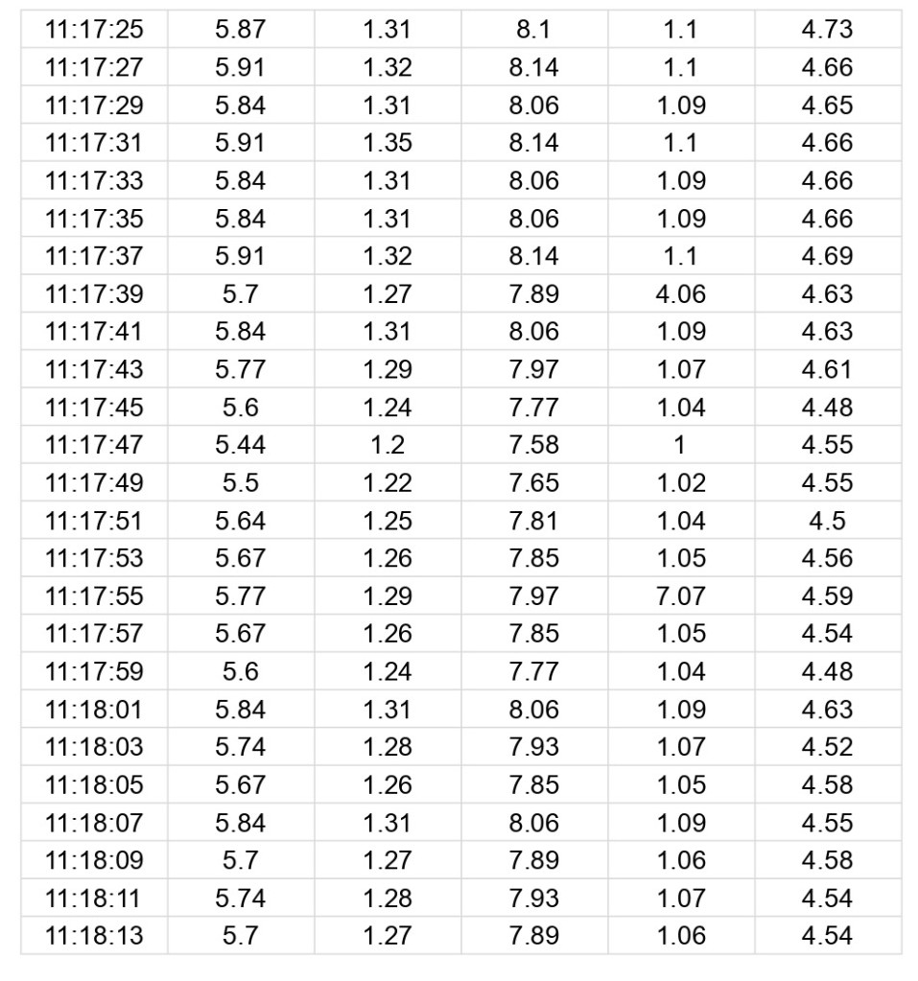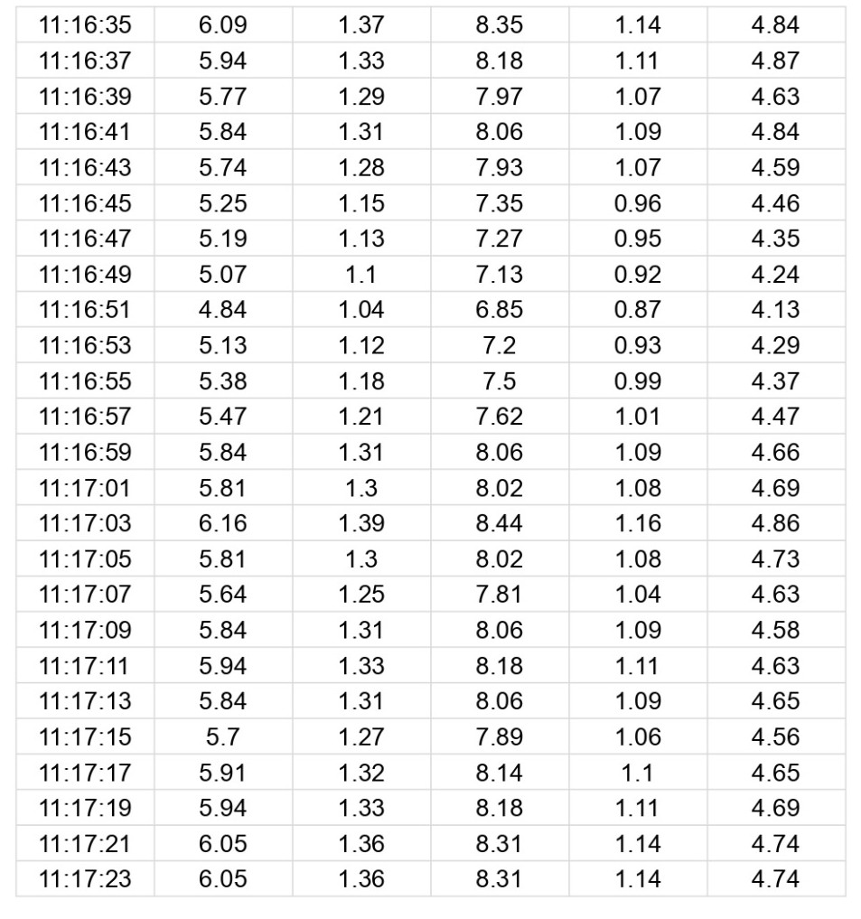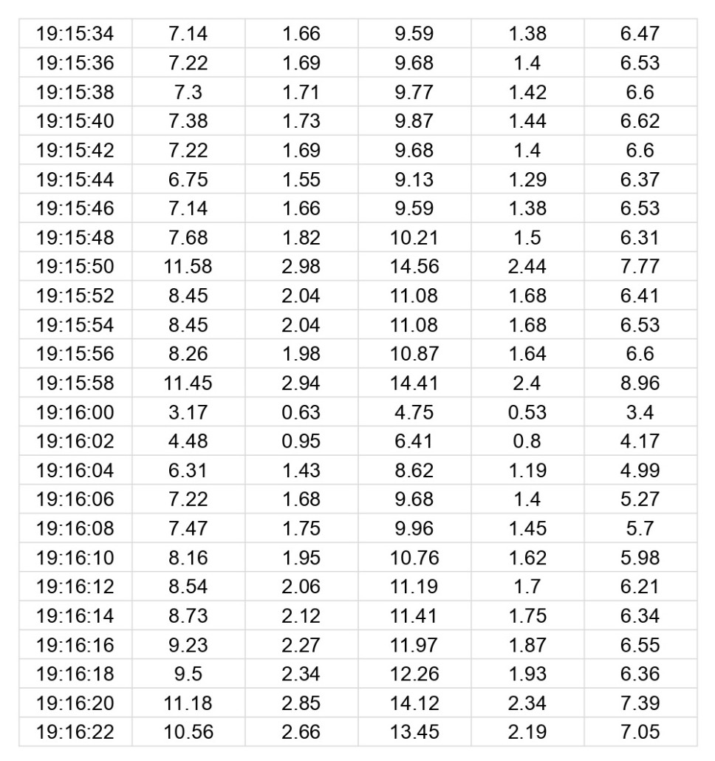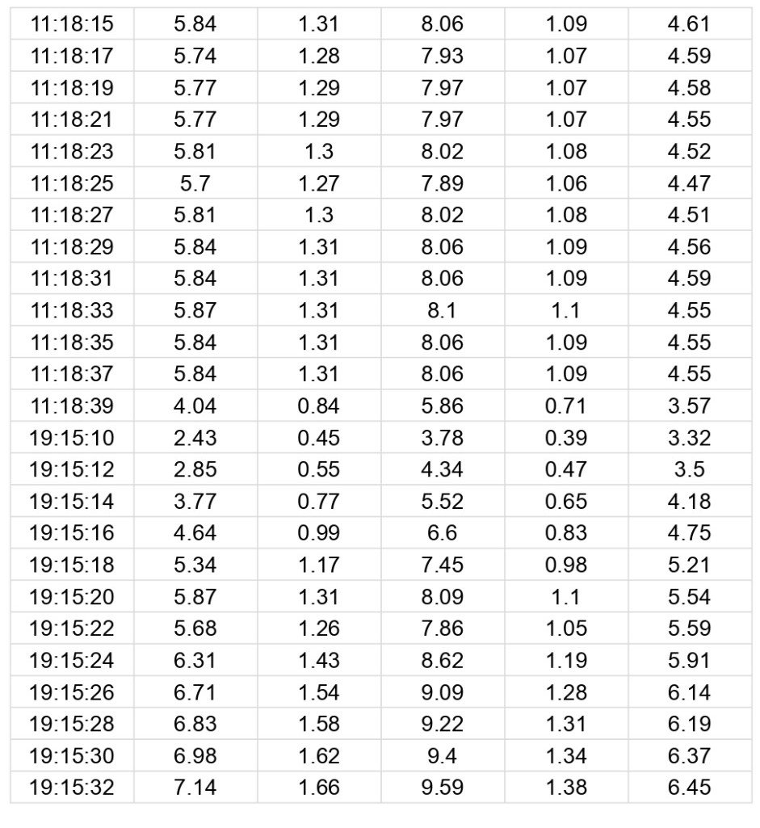

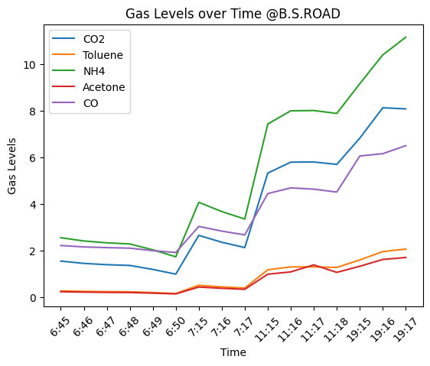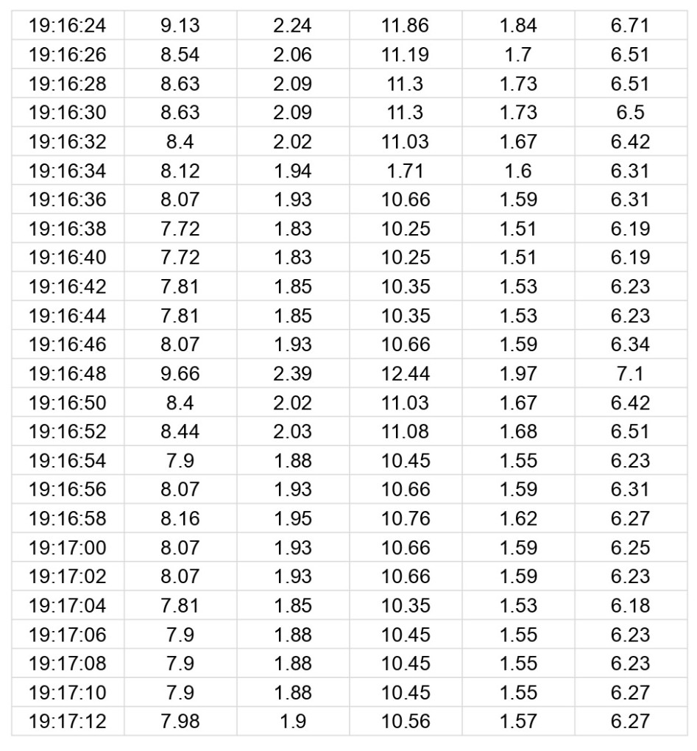

**Figure 6.** Air quality of B.S.Road

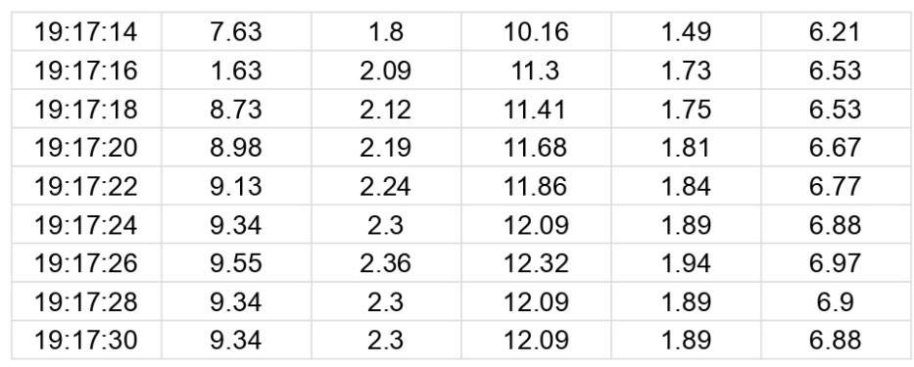

Visualize this to better Under standing

For making Data Visualization We make Average this dataset to per minute time wise

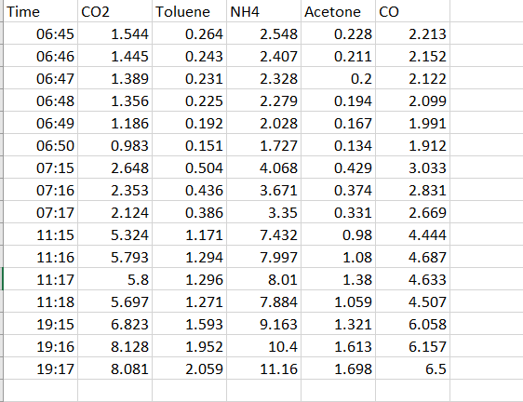

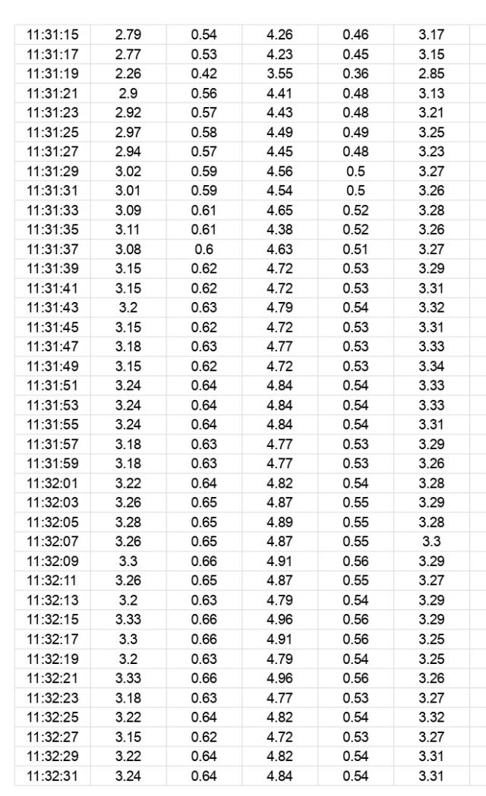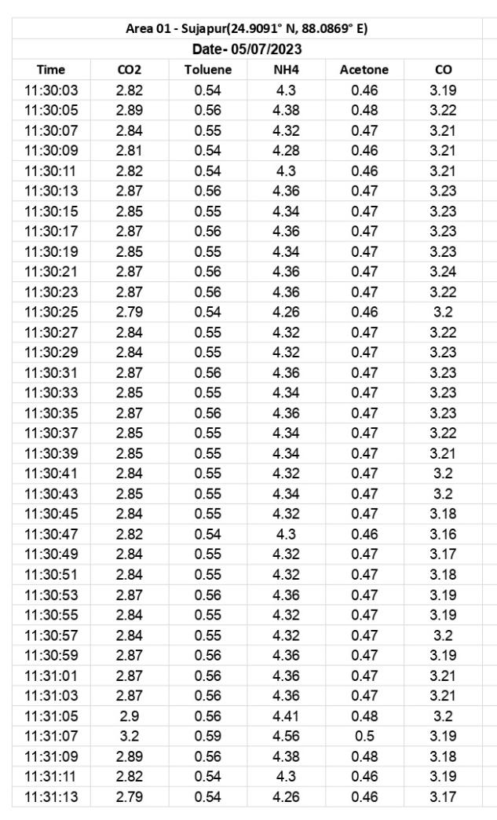

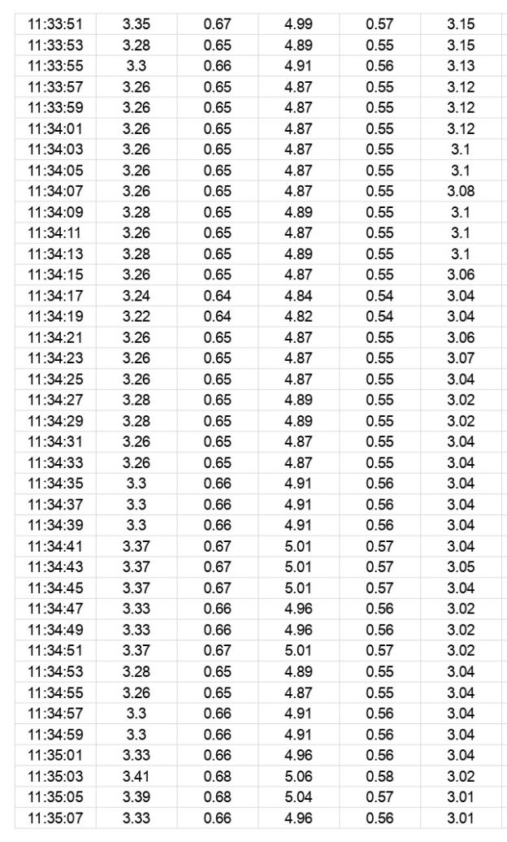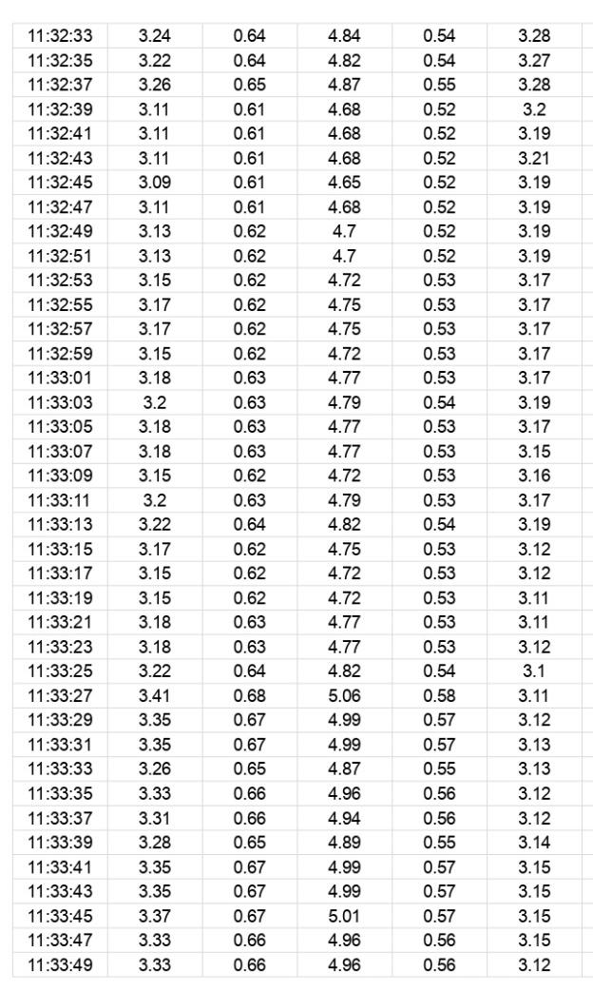

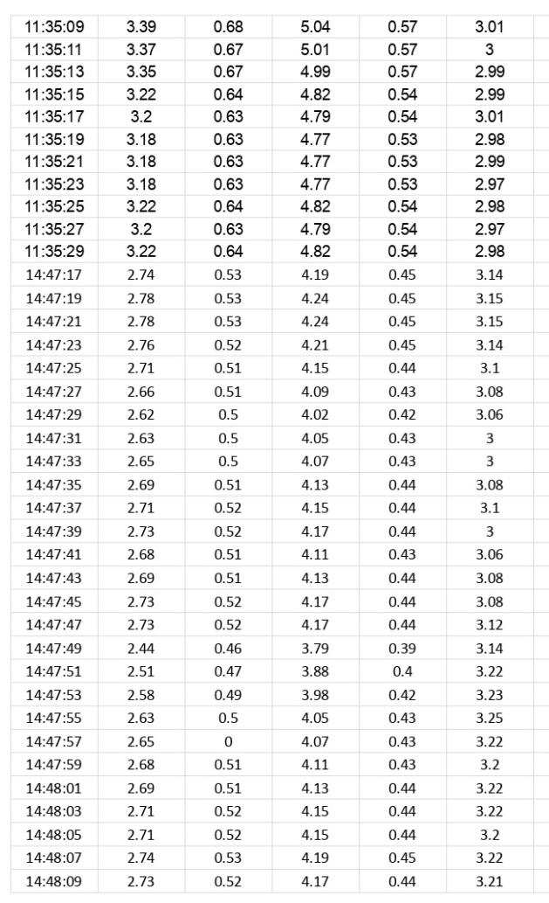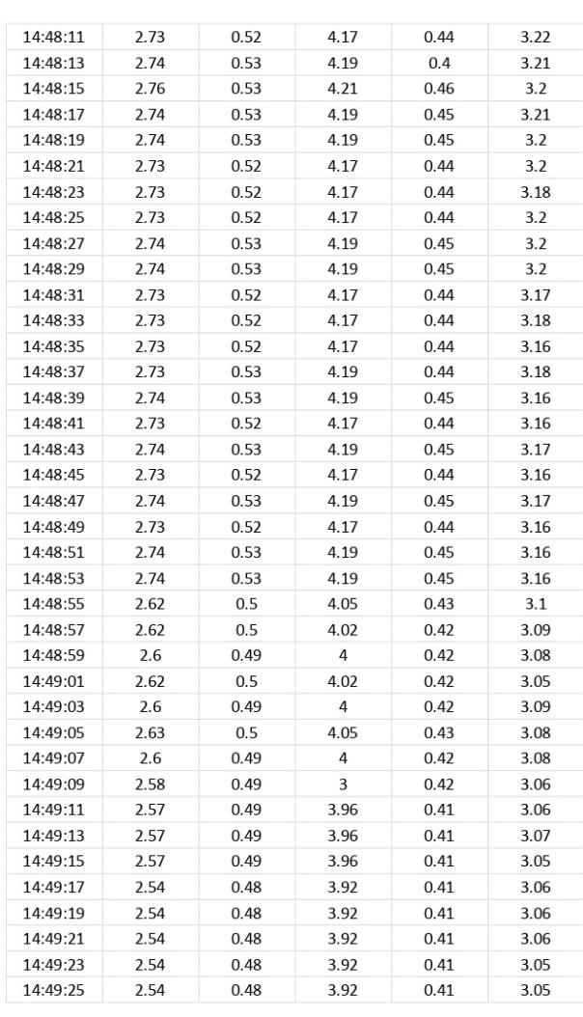

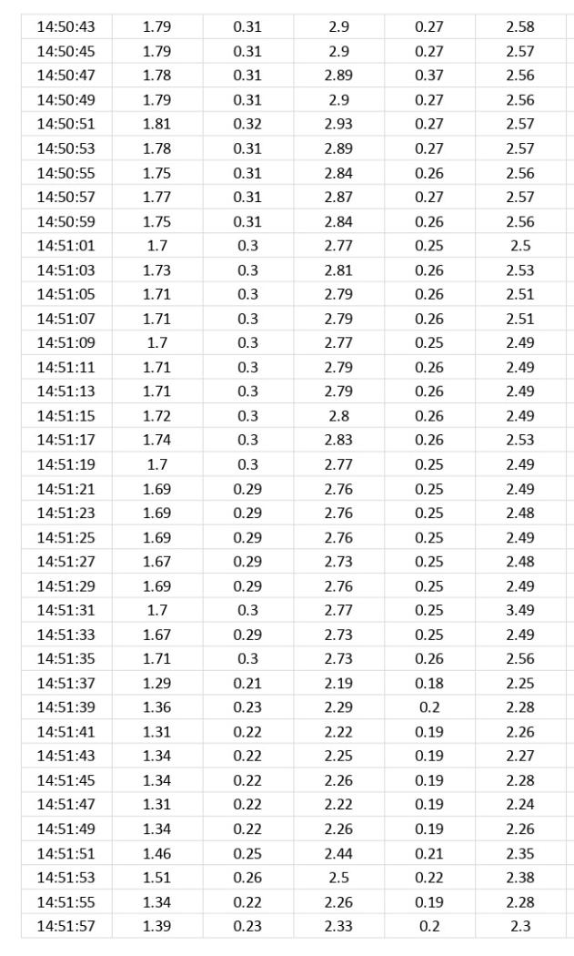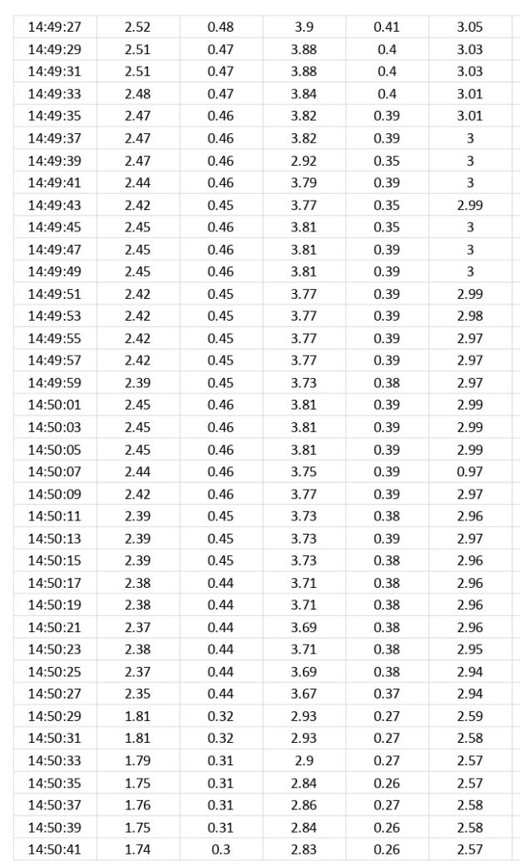

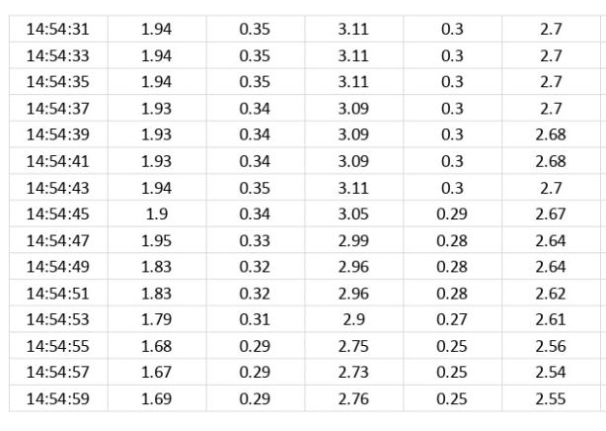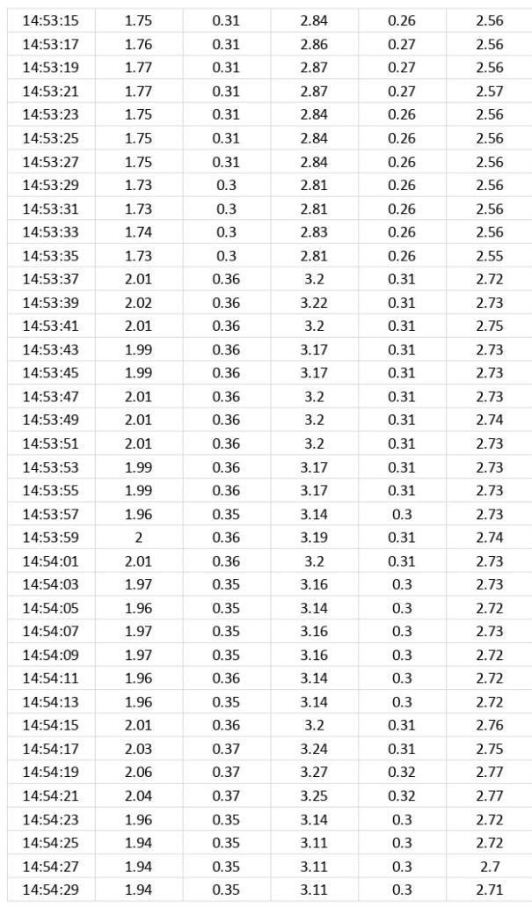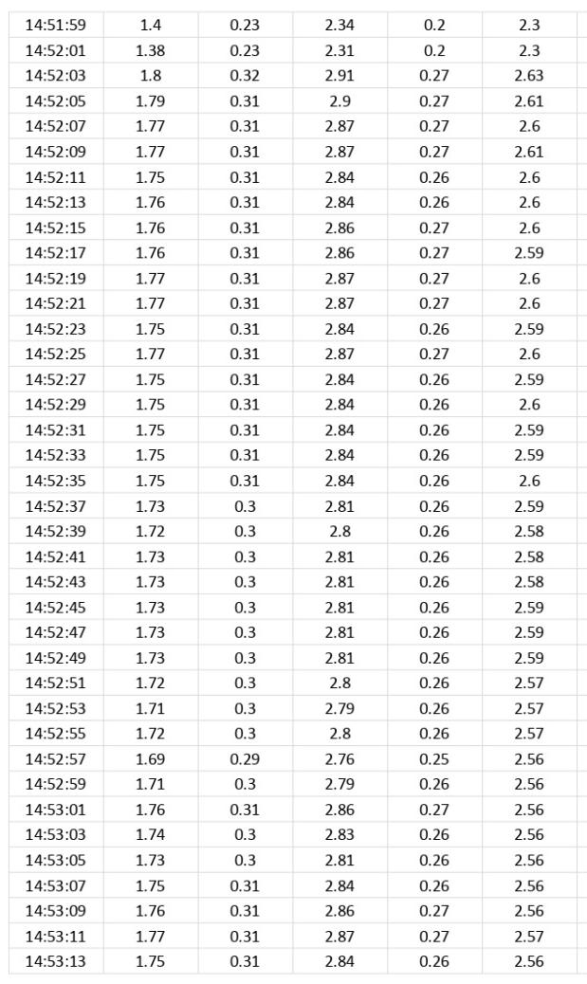

For making Data Visualization We make Average this dataset to per minute time wise

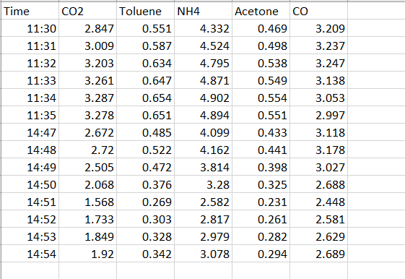

Visualize this to better Understanding

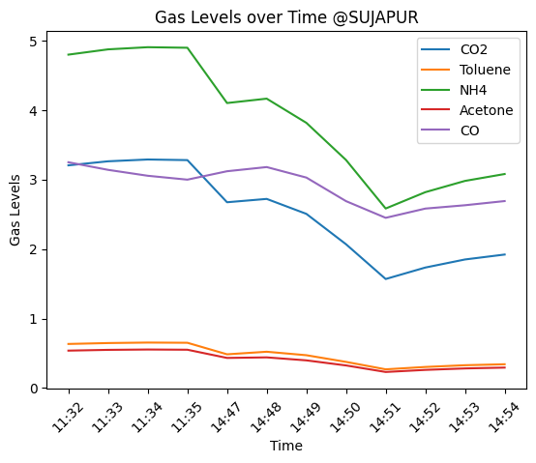

**Figure 7.** Air quality of Sujapur

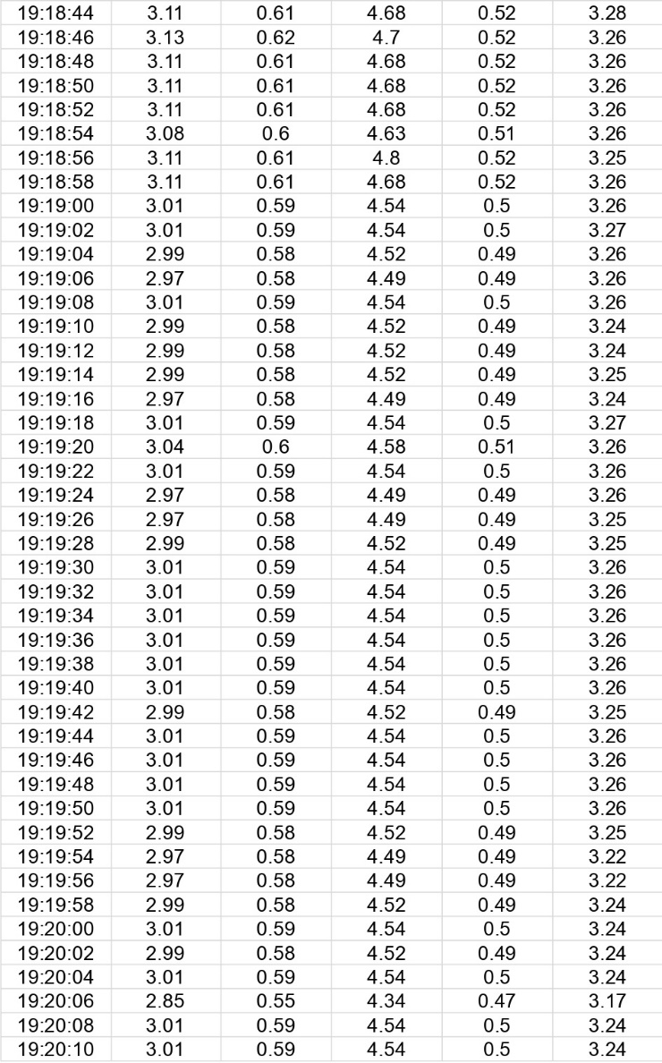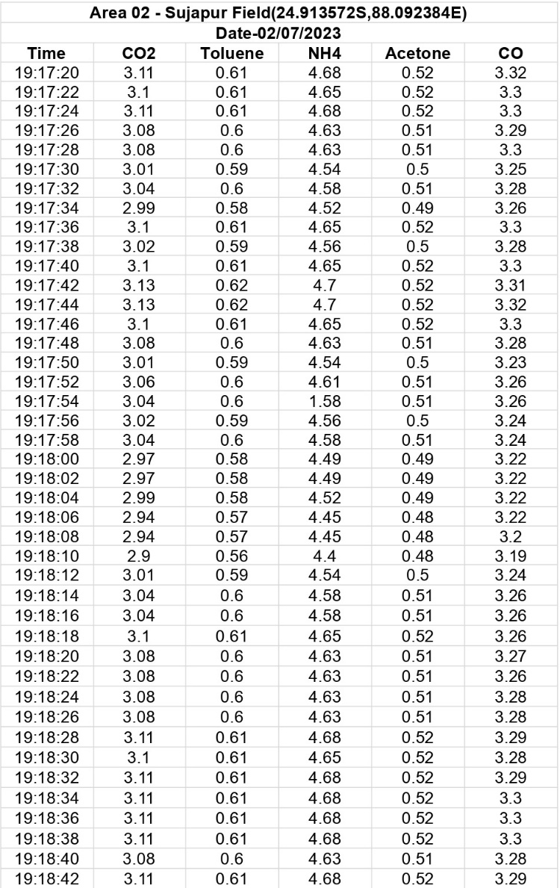

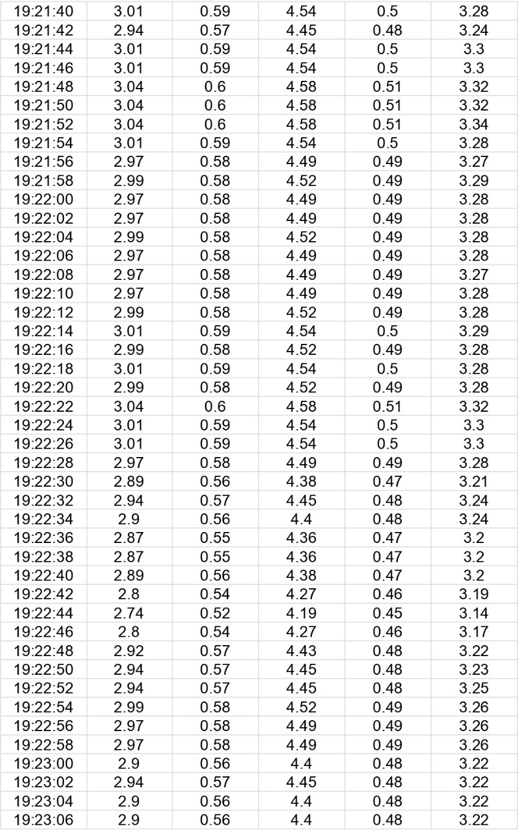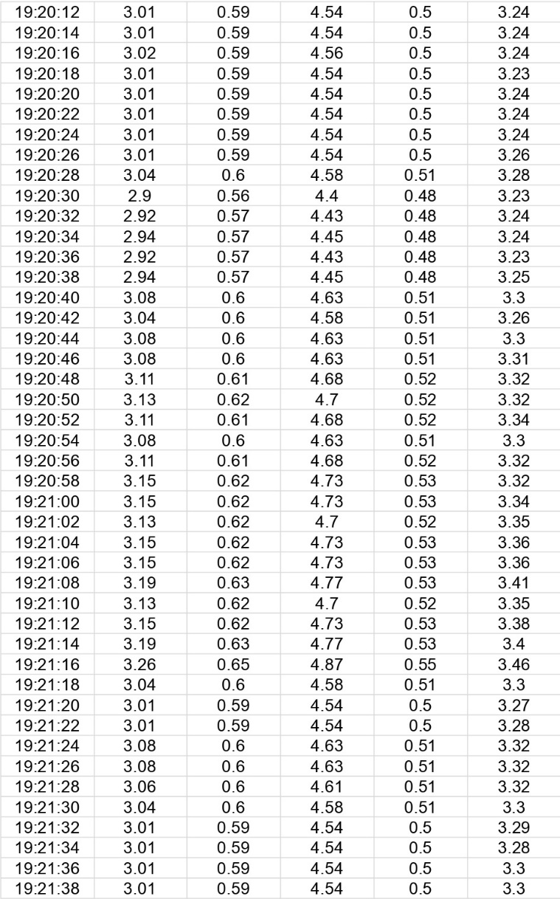

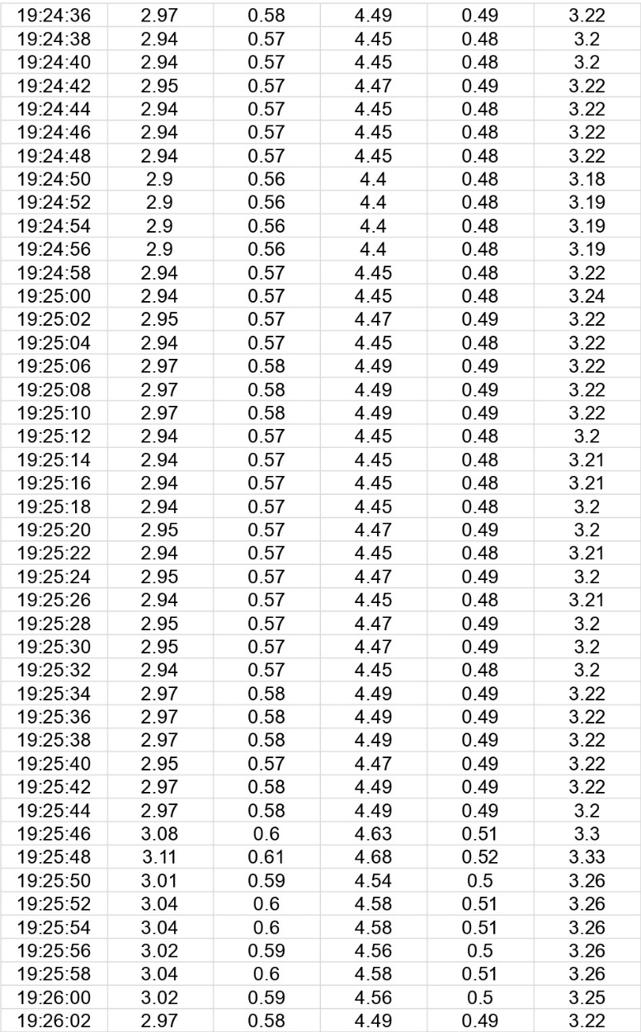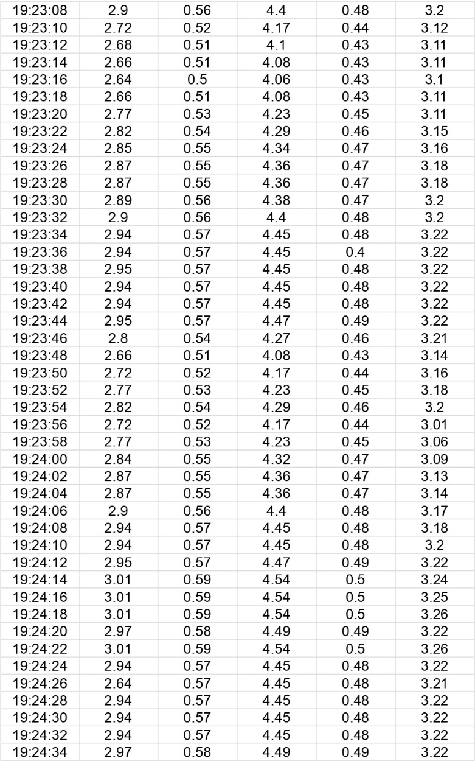

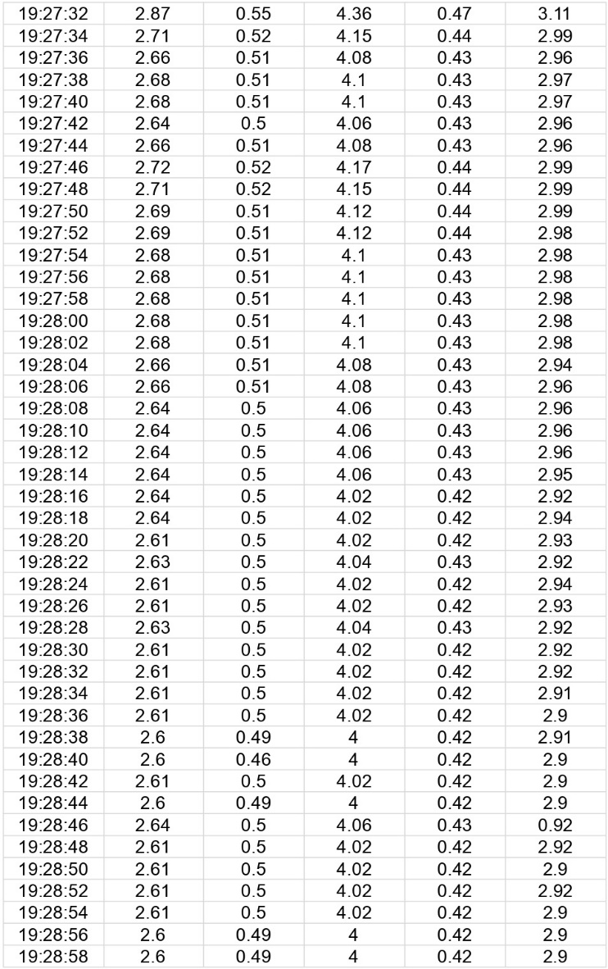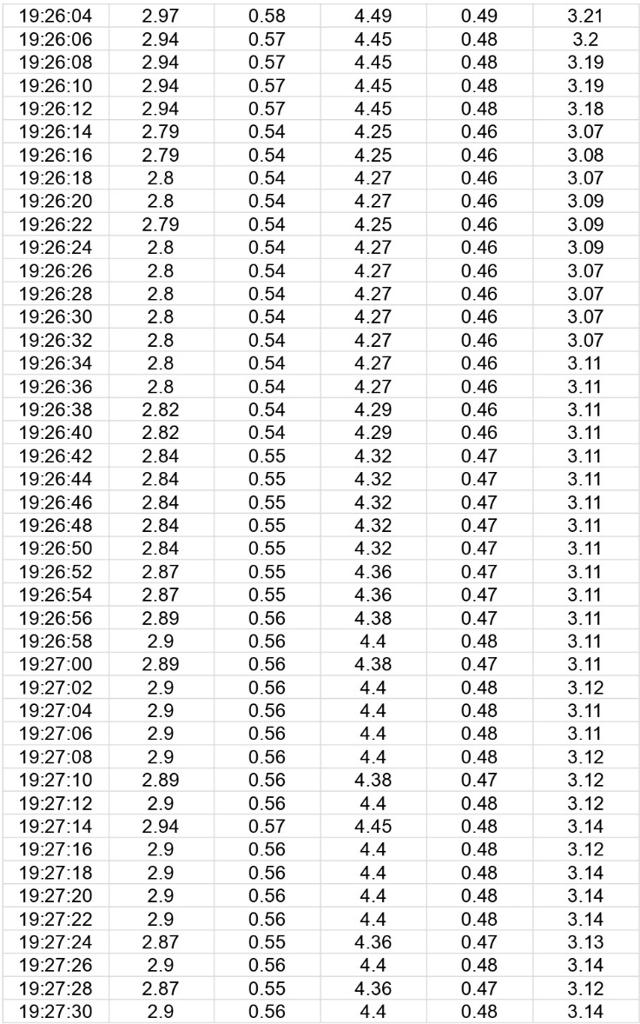

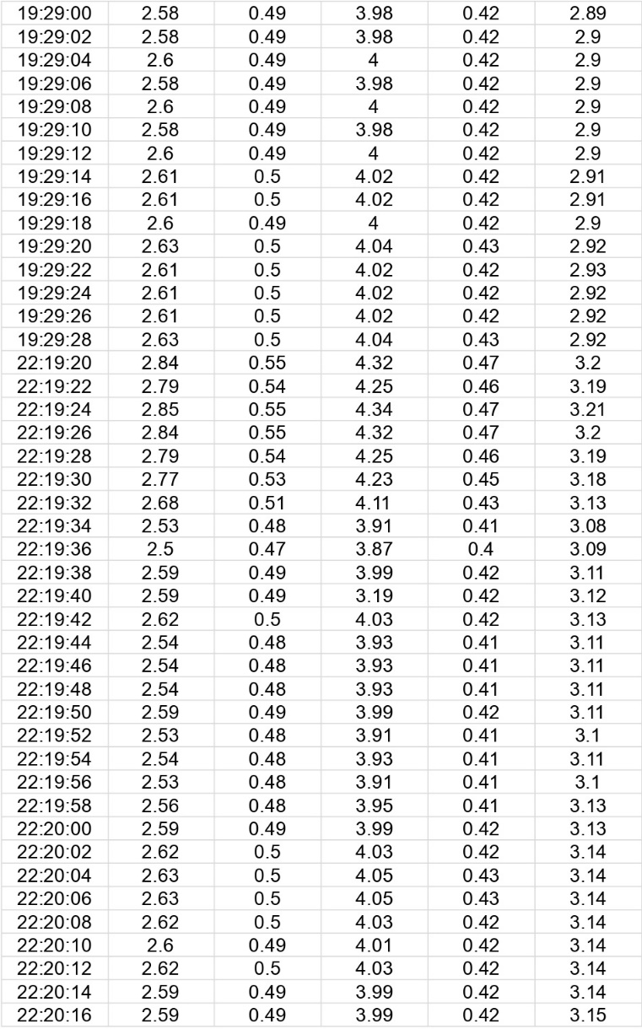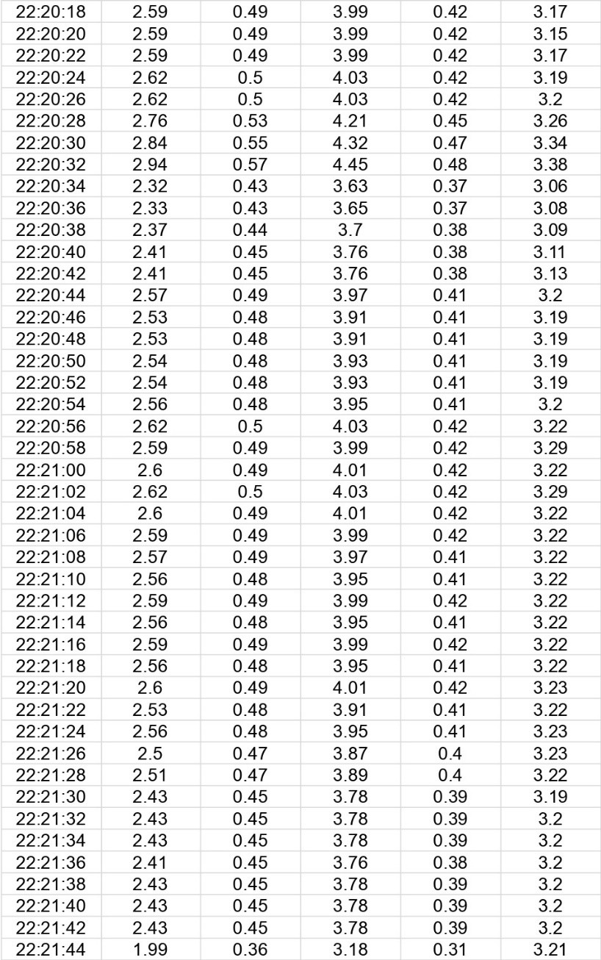

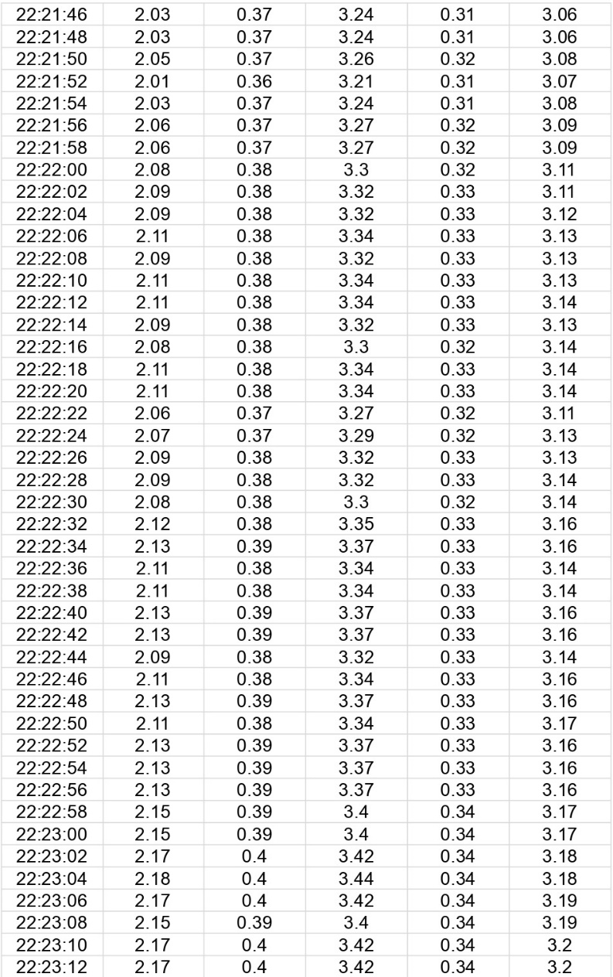

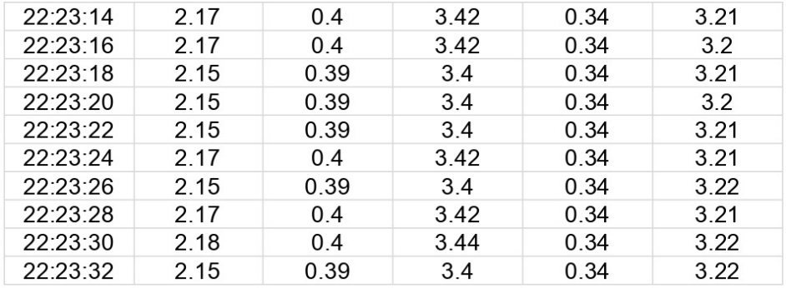

For making Data Visualization We make Average this dataset to per minute time wise

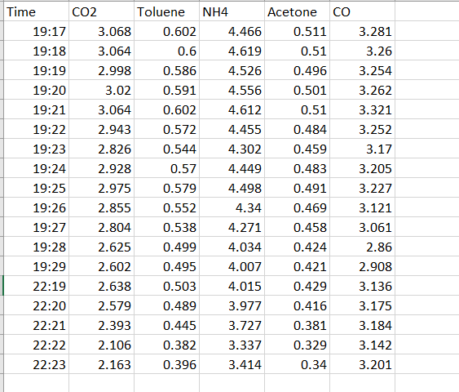

Visualize this to better Understanding

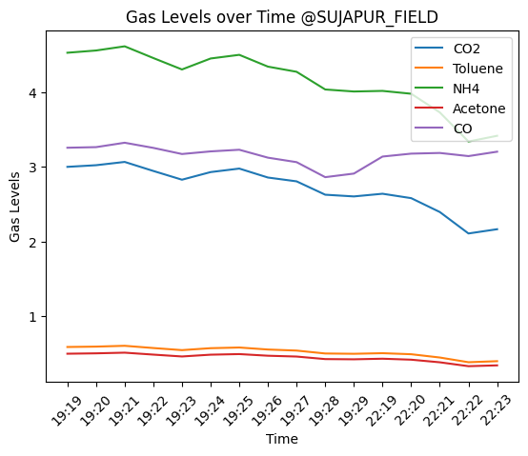

**Figure 8.** Air quality of Sujapur Field



**Figure 6.** Air quality of B.S.Road

**Figure 5.** Air quality of Rathbari



**Figure 8.** Air quality of Sujapur Field

**Figure 7.** Air quality of Sujapur

Figure 4-7 shows that when we measured the levels of pollutants at different times at different location. At Morning, the air quality showed very low quality of pollutants. However as soon as the sensors detected the presence of (CO2, Toluene, NH4, Acetone, CO) particles, the pollutant levels sharply rose at noon, because when vehicles burn fossil fuels, they emit CO2 into the atmosphere and refrigerators and air conditioners also emit this type of pollutants. Heavy- duty vehicles such as trucks and buses emit more CO2, Acetone & CO because of they burn fuel at a higher temperature. Toluene is emitted from a variety of sources, including vehicle exhaust, industrial processes, and waste disposal. Traffic is a major source of NH4 pollution because vehicles emit small amounts of ammonia, primarily from the exhaust of diesel engines. Diesel engines contain high levels of nitrogen, which can react with oxygen in the air to form ammonia. Ammonia can then be emitted into the atmosphere, where it can contribute to air pollution.

As per Figure 5 we came to this decision to determine the best time to assess air quality is crucial in the context of the IoT-based air pollution monitoring system. By identifying periods with lower pollution levels, this information can guide various stakeholders, including individuals, authorities, and industries, in making informed decisions to minimize exposure to harmful pollutants.

In this study, we found that urban areas like Rathbari and B.S. Road have higher air pollution levels. This is mainly because of the larger population, industrial activities, and heavy traffic in these areas. On the other hand, rural areas like Sujapur may have higher levels of certain pollutants due to agricultural activities.

To improve air quality and protect the health of people living in these regions, it is important to implement targeted pollution control measures. Continuous monitoring of air quality is essential to track the effectiveness of these measures over time and ensure a healthier environment for everyone.

1. **Conclusion**

The air pollution monitoring system project has been successful in achieving its main objective, which is to monitor air quality in industrial and urban areas. The system utilizes IoT (Internet of Things) technology, gas sensors, Arduino microcontroller to continuously measure, analyze, and log air quality data.

* More Functionalities

In future we can add more functionalities in this project for improving accuracy to find the polluted area and predict its best time and place among those areas.

We can also add Wi-Fi module, buzzer, humidity sensor and more sensors to send the collected data to a particular system or device if the area is polluted then a message will be sent to user or nearest controller.

1. **Reference:**
2. <https://www.who.int/health-topics/air-pollution#tab=tab_1>
3. Matthews V.O., Uzairue S.I., Noma-Osaghae E., and Nwukor F., Design and Simulation of a Smart Automated Traffic System in a Campus Community.", International Journal of Emerging Technologies and Innovative Research (www.jetir.org | UGC and issn Approved), ISSN:2349-5162, 5 (8), 2018, pp. 492-497, Available at: http://www.jetir.org/papers/JETIR1807794.pdf.
4. <https://en.wikipedia.org/wiki/Air_pollution>
5. <https://www.unep.org/news-and-stories/story/six-reasons-why-healthy-environment-should-be-human-right>
6. Environmental and Health Impacts of Air Pollution: A Review -[Ioannis Manisalidis](https://pubmed.ncbi.nlm.nih.gov/?term=Manisalidis%20I%5BAuthor%5D),1,2,*† [Elisavet Stavropoulou](https://pubmed.ncbi.nlm.nih.gov/?term=Stavropoulou%20E%5BAuthor%5D),3,*† [Agathangelos Stavropoulos](https://pubmed.ncbi.nlm.nih.gov/?term=Stavropoulos%20A%5BAuthor%5D),4,† and [Eugenia Bezirtzoglou](https://pubmed.ncbi.nlm.nih.gov/?term=Bezirtzoglou%20E%5BAuthor%5D)2,†
7. <https://pollution.ucr.edu/primary-vs-secondary#:~:text=Primary%20air%20pollutants%3A%20Pollutants%20that,lower%20atmosphere%20by%20chemical%20reactions>.
8. Ambient (outdoor) Air Pollution - <https://www.who.int/news-room/fact-sheets/detail/ambient-(outdoor)-air-quality-and-health>
9. The cost of a polluted environment: 1.7 million child deaths a year, says WHO|6 March 2017 |News release| <https://www.who.int/news/item/06-03-2017-the-cost-of-a-polluted-environment-1-7-million-child-deaths-a-year-says-who>
10. The respiratory impacts of air pollution in children: Global and domestic (Taiwan) situation

[I.-Ping Wu](https://pubmed.ncbi.nlm.nih.gov/?term=Wu%20IP%5BAuthor%5D),a,d [Sui-Ling Liao](https://pubmed.ncbi.nlm.nih.gov/?term=Liao%20SL%5BAuthor%5D),b,d [Shen-Hao Lai](https://pubmed.ncbi.nlm.nih.gov/?term=Lai%20SH%5BAuthor%5D),c,d,∗ and [Kin-Sun Wong](https://pubmed.ncbi.nlm.nih.gov/?term=Wong%20KS%5BAuthor%5D)c

1. <https://www.researchgate.net/publication/350679256_IoT_Based_Air_Pollution_Monitoring_System>
2. [https://www.ijser.org/researchpaper/IOT-Based-Air-Pollution-Monitoring-System .pdf](https://www.ijser.org/researchpaper/IOT-Based-Air-Pollution-Monitoring-System%20%20.pdf)
3. <https://www.ripublication.com/ijcse19/ijcsev9n1_01.pdf>
4. <https://www.jncet.org/Manuscripts/Volume-8/Issue-4/Vol-8-issue-4-M-23.pdf>
5. <http://www.iaeme.com/IJCIET/index.asp>
6. <https://jayconsystems.com/blog/understanding-a-gas-sensor>
7. https://docs.arduino.cc/software/ide-v2/tutorials/ide-v2-serial-monitor